Simulation

Task 3

**Machine**

Group Members:

Ahmad abd El-Latif Mhana(1)

Ahmad Magdy (1)

Ahmad Alaa Abd El-Wahab(1)

Problem formulation

&

Setting the Objective

Problem is that we want to decide whether the current method is better or the proposed one, in money wise.

The current method changes each bearing only if it fails.

The Proposed Method Changes the Three Bearings in the system as soon as any one fails.

Our goal is to decide the better method in money wise.

Model Conceptualization

The system consists of an abstract class “Module”, and class “CurrentModule” & “ProposedModule” inherits from it, I use the current Module to create the proposed module’s data.

This is for the single trial, so for the multiple trials I use “simulationMananger” Class that controls the number of trials I need.

I hold the data in two nested lists, or a table of a class names “bearingItem”, it represents a row in from the current module Bearing life column.

EXPERIMENTAL DESIGN

The length of the simulation runs = 100

The impact of different distributions = Unknown

The impact of the different stopping conditions

For a 100 Run simulation I found:

|  |  |
| --- | --- |
| Current Module | Proposed Module |
| Bearings Cost Avg: 1478.72$  Delay Cost Avg: 3497.5$  Downtime cost avg: 9242$  Pepairpersons avg: 462.1$  Total Cost avg: 14680.32$ | Bearings Cost Avg: 1719.36$  Delay Cost Avg: 1356$  Downtime cost avg: 7164$  Pepairpersons avg: 358,2$  Total Cost avg: 10597.56$ |

Results analysis

& Conclusion

For the Current Method

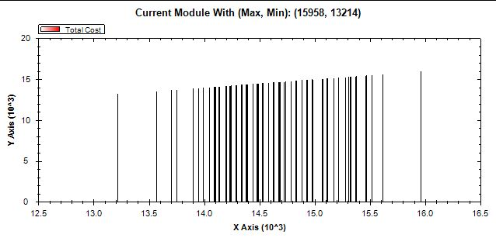

For the Proposed Method

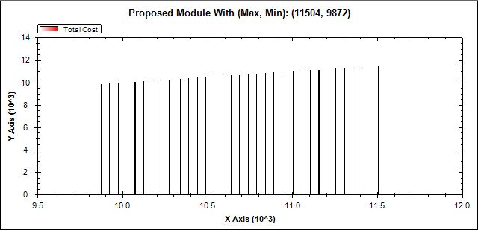

Form

Current

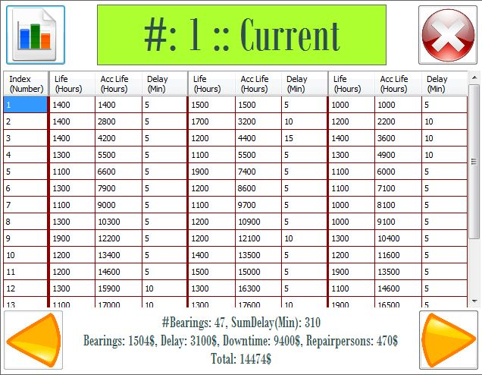

Proposed

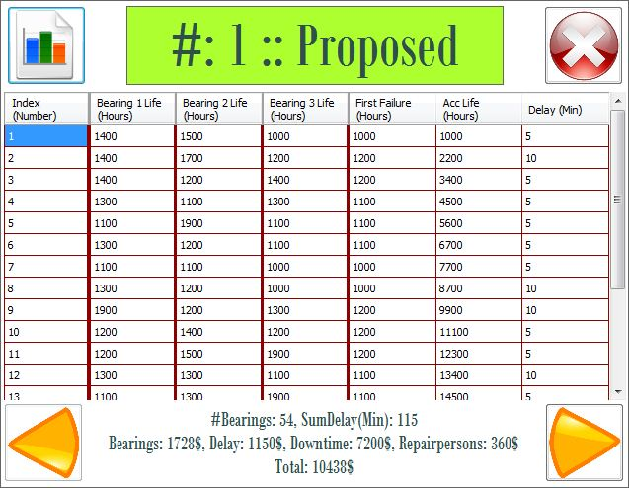

Conclusion

Form the data we have for the current and the proposed method for a 100 trails, we can say the proposed method is better, because it saves thousands of dollars for 20,000 hours of work.